Sustainability Website Report

**The main features that have been implemented are:**

* Bootstrap
* Realtime DB
* User Authentication
* Website Security
* User Statistics

**Two features that will be a great addition for the future:**

* Badge Reward for concurrent users
* Email Subscription for a follow up.

**Known Issues:**

* In some screens the pictures in the main page break into rows losing the original alignment given.
* In the pledge page the buttons uncheck when you go to the next page. (The results are still saved for the statistics)

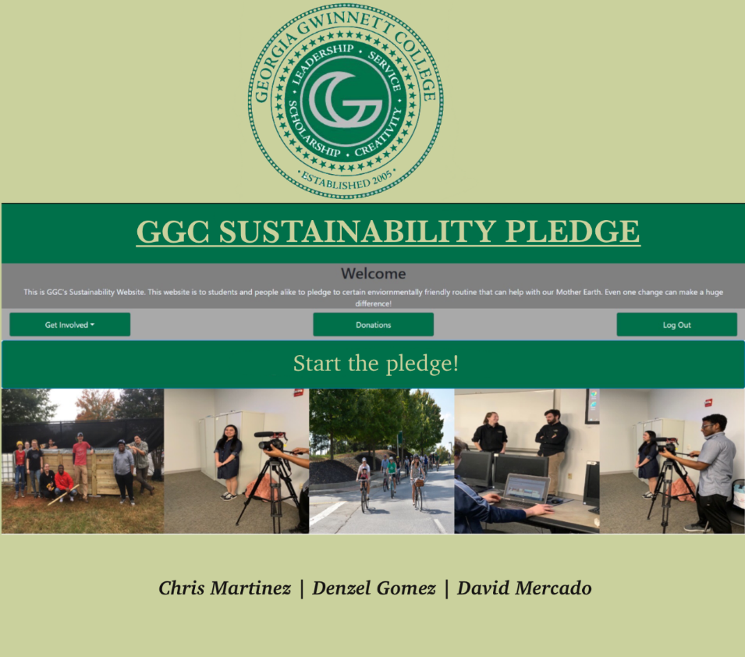**Project Flyer:**

**Demoing the project live on Discord:**

(Issues uploading it <https://www.youtube.com/watch?v=TkO5ufSxIkk&feature=youtu.be>)

**Team and client information**

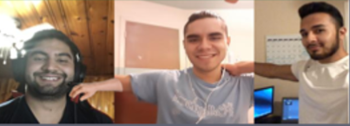

(From left to right: David, Chris and Denzel)

David Mercado: 21 Soft Dev, [dmercado@ggc.edu](mailto:dmercado@ggc.edu), Love Sports and Gaming.

Chris Martinez: 21, Soft Dev, [cmartinez5@ggc.edu](mailto:cmartinez5@ggc.edu), Love Guitar and Gaming.

Denzel Gomez: 24, Soft Dev, [dgomez3@ggc.edu](mailto:dgomez3@ggc.edu), Love Gym and Gaming.

Client: **Le Quang Greatzel Unabia**

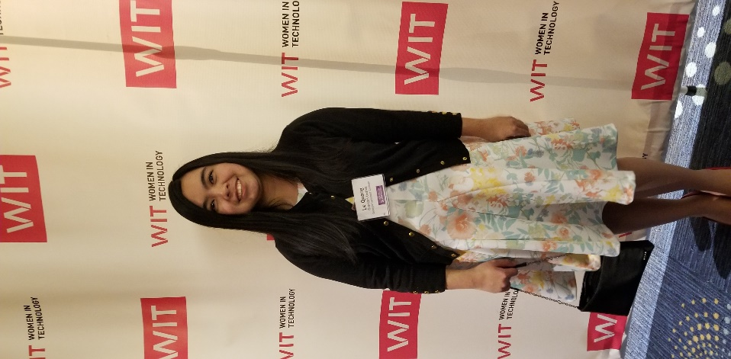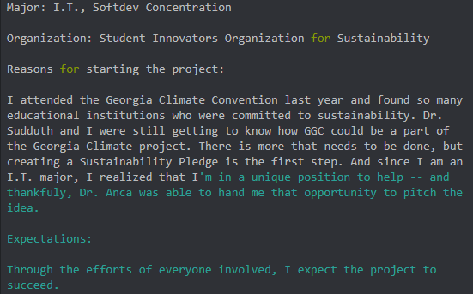

**Testing coverage, methods, and results**

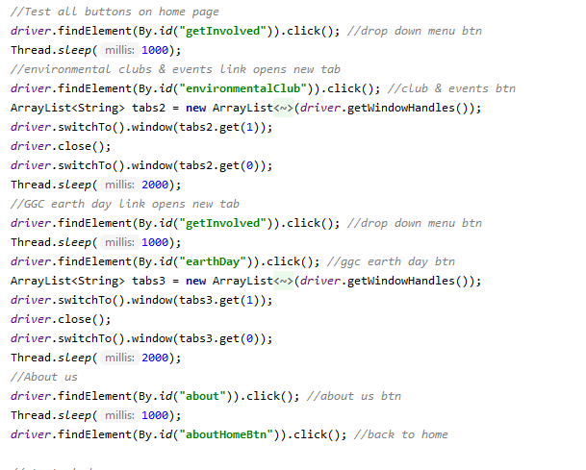

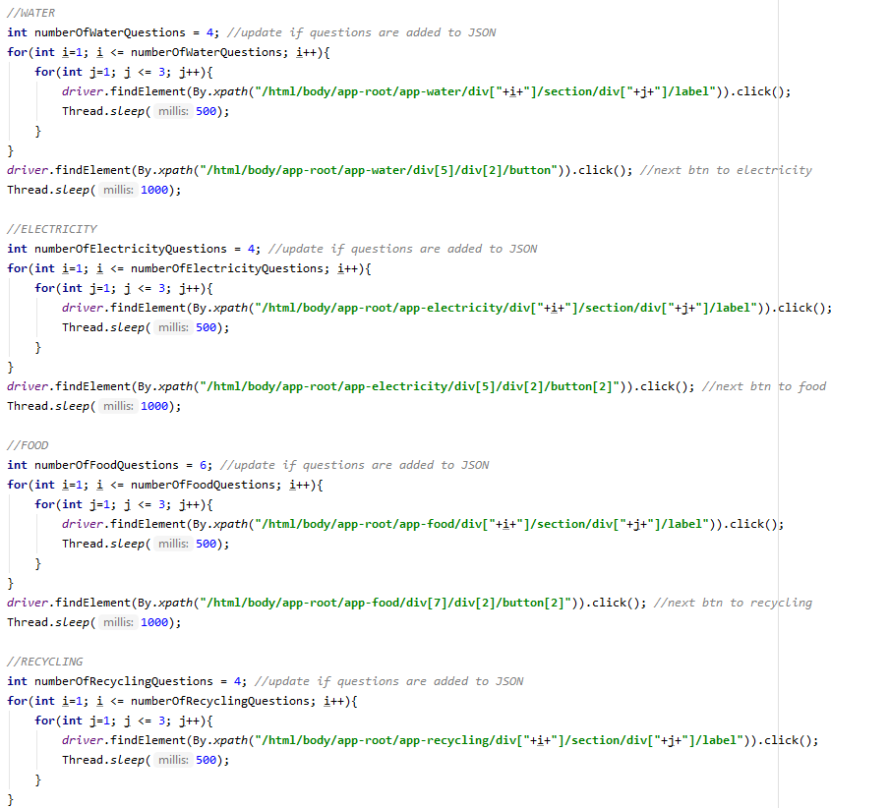

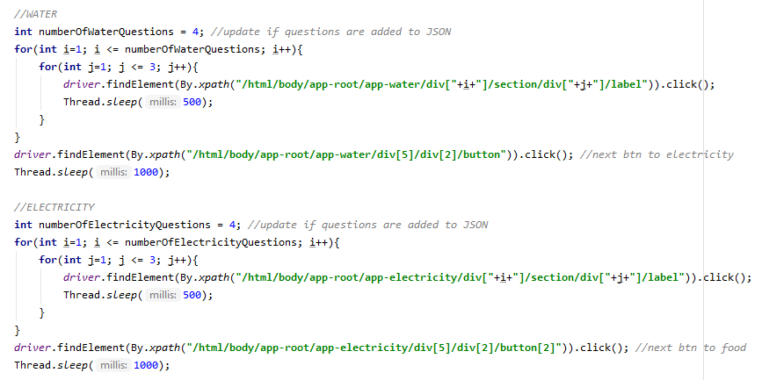

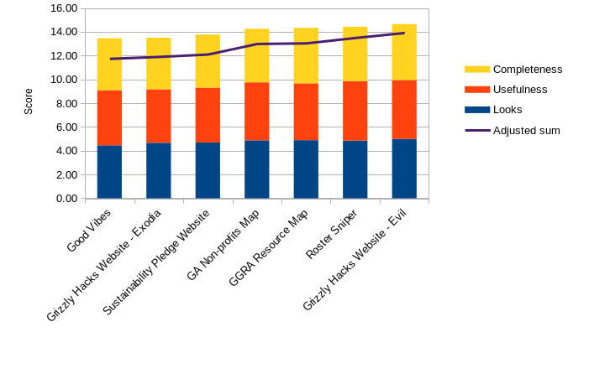**Usability testing and focus group survey results**

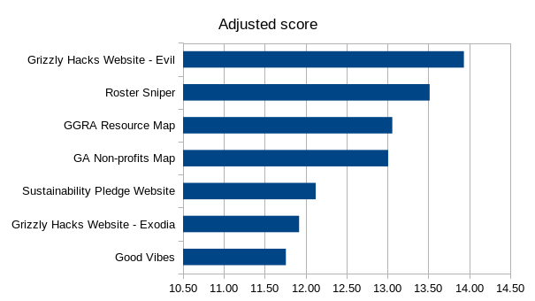

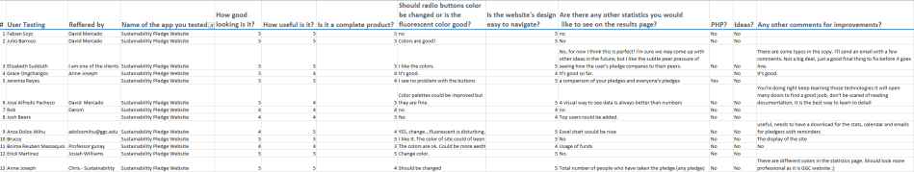

**Where to find installation, developer, and user documentation:**

* All of this can be found at our Git hub repository

<https://github.com/GGC-SD/SustainabilityWebsite>

The client will be able to access the Realtime database and the authentication list of users at our project that is deployed at Firebase, we have created and admin user:

Email: [SusPledgeGGC@gmail.com](mailto:SusPledgeGGC@gmail.com)

Password would be sent to the client in an email

Project instructions:

* Angular CLI 9 and Node 12.16.1 need to be installed
* Visual studio code is suggested to edit the code
* The admin would need to clone the repository from Git Hub
* Open Command Prompt and direct to where you clone the project, then do cd to go to the project until you reach SustainabilityPledge folder
* Write npm install in the command prompt
* Open the project (with visual studio just type “code .”)
* To run the project, write “ng serve -o”

**Burn down chart for last sprint**

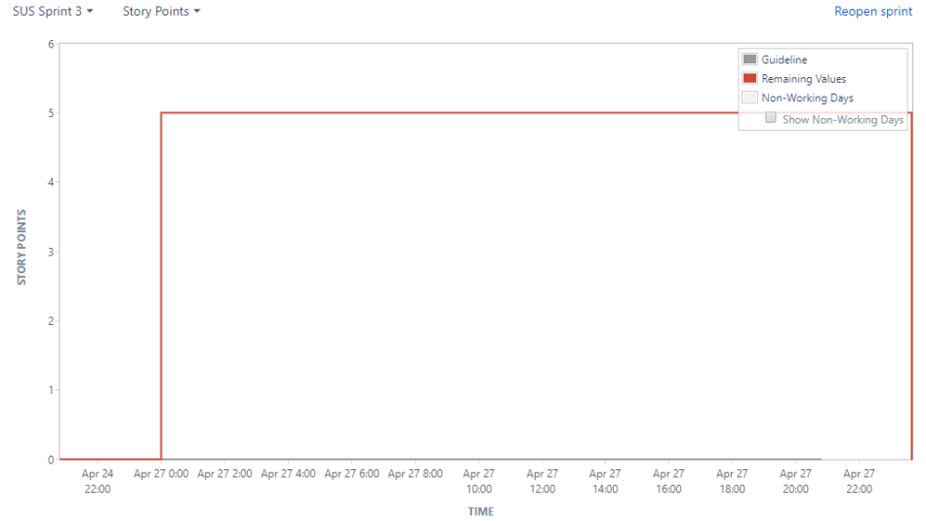

**Software Usage License signed by team members and client**

